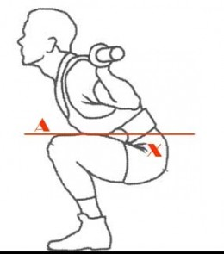
Squats
Proper technique:
- Straight head positioning. Looking down will automatically throw your spinal alignment off. Pick a spot on the wall in line with your eyes and keep looking at that spot.
- Athletic stance. Make sure your knees are slightly bent; feet firmly planted and toes pointing slightly outwards.
- Exhale up/inhale down. Take a deep breath as you lower down and then breathe out forcefully as you are pushing up, this will avoid light headedness.
- Chest out/shoulders back. Make sure your spine is in proper alignment. By keeping your shoulder back and your chest out, your lower back will most likely have the correct natural curve.
Common mistakes:
- Lifting the heel off the ground. This causes greater compression on ligaments and tendons in the knee, which can cause serious damage to the knee joint.
- Knees caving inwards. This usually indicates weak glutes, adductors or poor mobility. If done this will completely throw off your form, and can be dangerous. Try using an empty bar bell or knee wraps to support yourself.

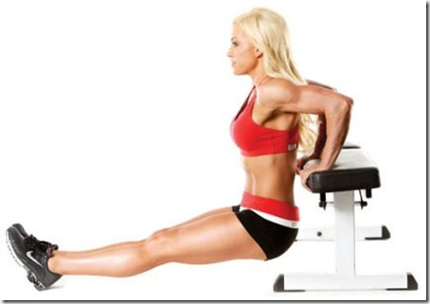
Tricep Dips
Proper technique:

- Position your hands shoulder-width apart on a secured bench or stable chair.

- Slide your body off the front of the bench with your legs extended out in front of you.

- Straighten your arms, keeping a little bend in your elbows to keep tension on your triceps and off your elbow joints.

- Slowly bend your elbows to lower your body toward the floor until your elbows are at about a 90-degree angle. Be sure to keep your back close to the bench.

- Once you reach the bottom of the movement, press down into the bench to straighten your elbows, returning to the starting position. This completes one rep.

- Keep your shoulders down as you lower and raise your body. You can bend your legs to modify this exercise.

Common mistakes:
- Rolling shoulders forward. To avoid straining the shoulder joints, make sure your shoulders aren't collapsing in toward the chest as you lower your torso.
- Performing the exercise too fast. This doesn’t allow you to recruit as many muscle fibres. Making the exercise less effective.
- Hands wide apart. This shifts the workload from your triceps to your chest.
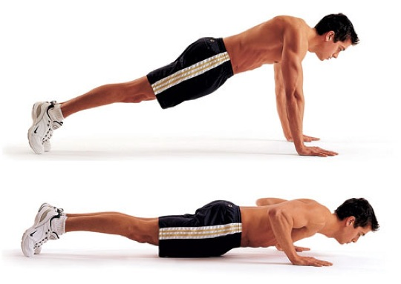
Press ups
Proper technique:
- Straight body. Straighten your back. Don’t sag at the hip or lift at the hips. It should be a straight line from head to toe. Check the mirror to see that your hips are in line.
- Feet together. Place your feet together. Incorrectly placing your feet will most likely result in sloppy form, which may result in injury.
- Hand placement. The width of your hands should be a little wider than shoulder width. However there are different widths to work different muscles. A narrower width will work the triceps whereas a wider width will work primarily the chest.
Common mistakes:
- Arched back. When you’re not strong enough to manage the push-up, your spine and/or head will sag toward the ground. This increases stress on the spine and shoulders.
- Relying on gravity. Don’t just drop to the floor. As you lower your body down, drive your palms into the floor and use your arms to pull your body to the ground. Think of doing a row on the way down. This will engage your upper back muscles and give you more of a workout.
- Elbows pointing outwards. This puts a lot of stress on your rotator cuff, which can lead to injuries. Instead, keep your elbow tucked as close to your body as possible.

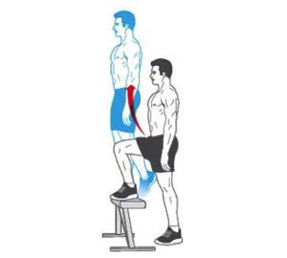
Step ups
Proper technique:
- Look straight ahead. This will improve your posture and form and help to improve coordination.
- Step up on to the bench. Don’t just stand on the floor, placing your feet on the bench. By stepping onto the bench you are activating the required muscles.
- Technique before speed. Learn the technique properly and then build your speed and intensity up.
- Use arms. Drive your arms in correlation with your legs to increase the speed of your movement.
Common mistakes
- Not moving your arms. Keeping your arms by your side will restrict the speed at which you can do the exercise; it will also affect your balance.

Shuttle runs
Proper technique:
- Drop hips. Do this as you turn to avoid running in an arc, saving time and energy.
- Push off. Push off strongly with your back foot to get back up to pace
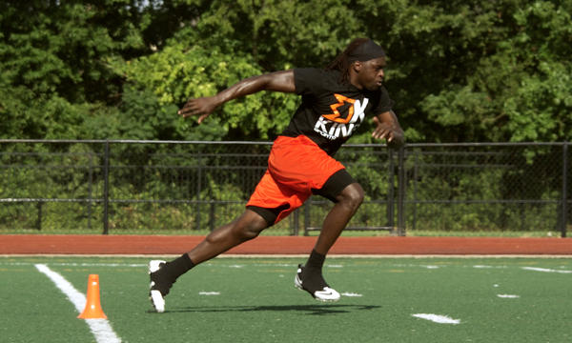
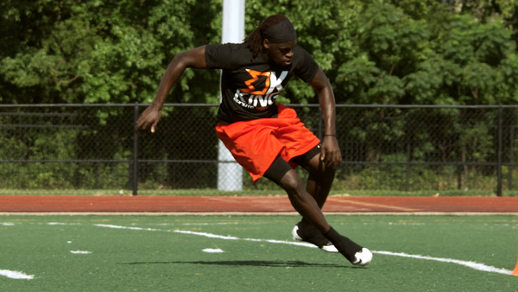
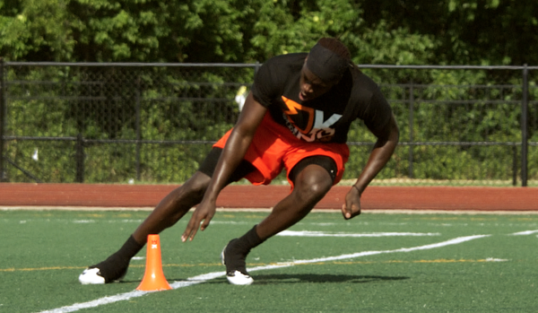
- Side on. Approach the line and turn side on, place one hand across the line. This will stop you having to completely turn around, which will lose you time. This also enables you to quickly push off your back foot. Alternate Which leg you turn on.

