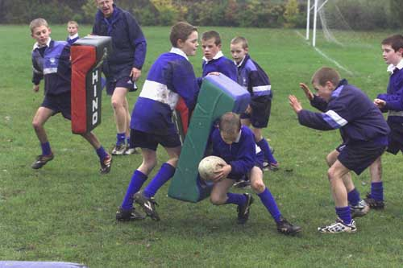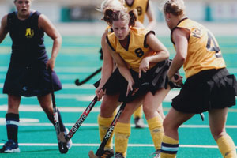

**A1 - Reasons for taking part in activity**

**SECTION A: EXERCISE and TRAINING**

|  |  |  |
| --- | --- | --- |
| **SOCIAL** | **MENTAL** | **PHYSICAL** |
| * Develops friendships and social mixing * Co-operation * Competition * Physical Challenge * Aesthetic appreciation | * Helps relieves stress/tension * Helps relieve stress related illness | * Helps individual to feel and look good * Enhances body shape * Contributes to good health and enjoyment of life |

**KEY DEFINITIONS**

* **Health** – State of complete mental, physical and social well-being.
* **Fitness** – The ability to meet demands of the environment
* **Exercise** – Form of physical activity done primarily to improve one’s health and physical fitness

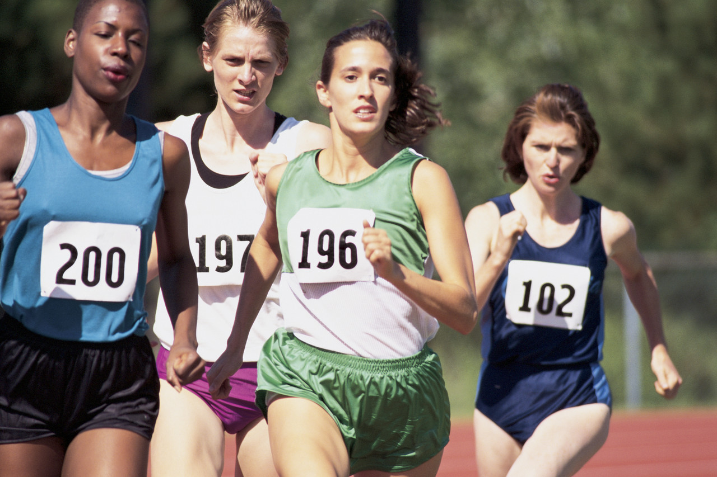

**A2 - HEALTH, FITNESS, EXERCISE and PERFORMANCE**

**CARDIOVASCULAR FITNESS** **–** the ability of the heart to pump blood and deliver oxygen where needed in the body. Relies on a healthy heart, blood and blood vessels

**Examples**

* Playing 90 minutes in football matches
* Playing Cricket matches that could last for 3-5 days
* Running in a marathon

**FLEXIBILITY –** movement at a joint to its fullest range

**MUSCULAR ENDURANCE –** The ability of muscles to move weight over a long period without tiring

**Examples**

* Long distance walking
* Long distance running
* Long distance swimming

**Examples**

* Hurdling in athletics
* Gymnastics – performing complex sequences
* Swimming -

**HEALTH RELATED COMPONENTS**

**SPEED –** Fastest rate at which a person can complete a task or cover a distance

**STRENGTH** is defined as the ability to lift a maximum weight in one attempt

**Muscular strength** – Can be seen in person lifting heavy weights.

**Examples**

* Running fast – 100m sprint
* Throwing a cricket ball at the stumps to get a run out

**Examples**

* **DYNAMIC** – required to start and maintain movement of the body ***e.g. cycling or doing loads of press-ups***
* **EXPLOSIVE** – required when a high amount of force has to be applied quickly ***e.g. shot putting***
* **STATIC** – required when applying strength to a fixed static object ***e.g. pushing in a rugby scrum***

**REACTION TIME –** The time it takes to respond to a stimulus (***simple***) or a variety of stimuli (***choice***)

**Examples**

* **SIMPLE** – responding to a signal ***e.g. sprint start to a gun***
* **CHOICE** – responding to a variety of signals ***e.g. playing a shot in cricket depending on length of the ball pitched***

**A3 - SKILL RELATED FITNESS**

**AGILITY –** Ability to change direction quickly and still be in control

**POWER –** Ability to apply a combination of speed and strength in an action

**SKILL COMPONENTS**

**Examples**

* Football - dribbling past an opponent at speed
* Rugby – Running, avoiding opponents whilst in possession

**Examples**

* Football – Goal keeper taking a goal kick
* Badminton – playing an overhead smash

**BALANCE –** Ability to keep the body stable whether still (***static***), moving (***dynamic***) or in a different shape by keeping centre of gravity over the base

**CO-ORDINATION –** Ability to use two or more parts of the body at the same time

**Examples**

* **STATIC** – holding a position without movement ***e.g. a handstand in gymnastics***
* **DYNAMIC** – maintaining a position whilst moving ***e.g. cycling or surfing***

**Examples**

* Pole vaulting
* Basketball – lay up shot
* Tennis – player taking a serve

There are several training principles, each influencing the training of the performer in a different way. Good training takes into account all of the principles and their effects on the body.

**S.P.O.R.T. Principles**

* **SPECIFICITY –** Understanding the needs of the game or event, e.g. a goalkeeper will include reaction work in their training. The pace of training should be consistent to the pace of the game. Also the actions should be the same in training as it is in match situations ***e.g. a swimmer needs to spend most of their time in the water.***
* **PROGRESSION -** Exercising at the same degree of difficulty all the time will only maintain current fitness levels. Your body needs to be put under more pressure in order to improve. The easier a session is to complete, the performer should start to progress the next session.
* **OVERLOAD –** Putting greater demands on the body by exercising. This can improve fitness. The point where exercise is demanding enough to have an effect on the body is called the *‘****threshold of training’.*** There 3 ways;  
  ***- Frequency – number of sessions e.g. up to 3 per week   
  - Intensity – increasing distances run, repetitions or weight  
  - Duration – length of training sessions***
* **REVERSIBILTY –** The body will increase in strength, tone and skill with exercise; however it also loses them without it. After injury or illness, an athlete can lose their strength and skill, up to 3x as fast as they gain it – ***‘If you don’t use it, You lose it!’***
* **TEDIUM –** Use different ways of training to give variety, keep interest and avoid boredom.   
  ***e.g.*** ***go bike riding instead of running***
* **INDIVIDUAL NEEDS -** Whether training to compete or training for health, everyone has different needs. People vary in height, size, shape and preference. Therefore, even though they have the same goals they may not reach them by the same means.

**A4 - PRINCIPLES OF TRAINING**

**F.I.T.T PRINCIPLES**

**FREQUENCY –** How often the exercise is done (be it an individual set or the whole session) – ***e.g. Training 3 times a week or 2 per day.*** Elite performers train more frequently to achieve results good enough. Remember, the body needs time to recover so training very, very hard, every day can be harmful even to an elite performer.

**INTENSITY –** The difficulty of the exercise – could be the amount of weight or the speed you move. Consider cardiovascular fitness, your pulse rate can show you how intensely you’re working. Fitness will increase by working in 60-80% target zone of the maximum heart rate, ***e.g. Training with heart rate of 120bpm – 160bpm.*** Strength training is similar, by calculating 60-80% of their maximum weight they can lift and working to it.

**TIME –** The duration of the Exercise. Keeping your pulse at 60-80% of its maximum for 2minutes is the target. The time begins once the pulse rate hits 60%. The warm up is not included. Also you can vary the duration of each session ***e.g. 30mins, 45mins or 60mins***

**TYPE –** What kind of exercise you do – For general fitness then personal preference to suit the individual is usually done ***e.g. swimming, cycling or running***, But if its for a specific activity then choice becomes limited as it should reflect the activity. However remember to vary to keep interesting and work all different muscle groups.

**TYPES OF CONTRACTION**

* **Isotonic Contraction** – In this contraction, the muscle changes length and so something moves. ***E.g. Bicep Curl***
* **Isometric Contraction** – In this contraction, the muscle stays the same length and so nothing moves. ***E.g. the Wall Sit***

**A5 - METHODS OF TRAINING**

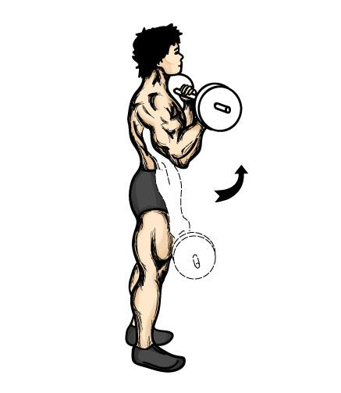

**AEROBIC and ANAEROBIC ACTIVITY**

**Aerobic** – with oxygen

* Lower intensity
* Endurance activities - Marathon

**Anaerobic –** without oxygen

* Higher intensity
* Short distance activities - Sprinting

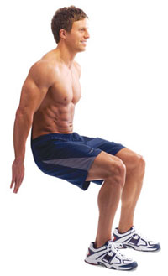

**TRAINING METHODS**

There are many types of training methods.

* **CIRCUIT TRAINING** – Has between 8 – 15 stations in it. Each station has a specific exercise to do. A short rest is allowed between each station.
* **WEIGHT** **TRAINING** – Improves **muscle strength and tone.** Be done in a gym using free weights.
* **INTERVAL TRAINING** – Mixing periods of hard exercise and rest periods. Similarity to games activities e.g. Rugby and Football
* **CONTINOUS TRAINING –** Exercising aerobically at a constant rate doing activities like running or cycling, with **no rests.**
* **FARTLEK TRAINING –** Swedish for ***‘speed play’*** - Changing speed, distances and times of exercise in same session.
* **CROSS TRAINING** – Uses a combination of different training methods.

**Effects of Exercise on the Body**

|  |  |  |
| --- | --- | --- |
| **Immediate Effects of Exercise** | **Effects of Regular Training** | **Long Term Benefits** |
| Heart Rate increases | Bigger and Stronger Heart -***Athletes heart*** | Helps prevent Heart Disease |
| Cardiac Output & Stroke Volume increases | Lower Resting Heart Rate | Helps prevent Type 2 diabetes |
| Blood Pressure increases | Improve Cardiac Output &  Stroke Volume | Helps prevent Cardiovascular Disease |
| Increase of Blood to working muscles | Lower Blood Pressure | Helps prevent Obesity |
| Skin becomes Red – Vasodilation of blood vessels | More Blood Vessels - Capillarisation | Improves General & Mental Health |
| Increase Tidal Volume | Improved VO2 Max | Helps prevent depression |
| Increase breathing rate – more Oxygen uptake | More efficient gaseous exchange | Boosts Immune System |
| Increase in Gaseous exchange – more blood to lungs | Stronger muscles, ligaments, tendons |  |
| Increase Flexibility in Muscles and joints |  |  |
| Sweat Production |  |  |

**A6 - DIET, HEALTH AND HYGIENE**

**BALANCED DIET –** Daily intake of food containing right amounts and types of nutrients

|  |  |  |  |
| --- | --- | --- | --- |
|  | **Function** | **Foods found in** | **Aid to Sportsperson** |
| **Carbohydrates** | Ready source of energy  Store of energy as Glycogen | Fruit, cakes, beer, sweets, granulated sugar and bread, pasta rice, potatoes. | Ready source of energy when muscles need it. Athletes training hard use carbohydrates quickly so diet should be high in this food type. |
| **Proteins** | Growth and Repair of tissues, enzymes and hormones | Meat, fish, pulses (chick peas, lentils and beans), nuts, eggs and poultry | Builds muscle and repairs tissue within body. Essential after injury to heal quickly. Sportspeople who have large muscles need extra protein. |
| **Fats** | Source of energy (slow release)  Can be stored in body | Milk, cheese, butter, oils, chocolate, fatty meats, soya beans and corn. | Increase size and weight of body beneficial to performers with extra bulk e.g. Shot putter. Excess weight can inhibit performance though. |
| **Vitamins** | Helps general health – vision, skin condition, forming of red blood cells and clotting, good condition of bones and teeth | Fruit – vitamin C  Liver, carrots – Vitamin A  Whole grain, nuts – Vit B1  Vegetable oil – Vitamin E | General health is important to perform well. When training hard vitamins from B group are used up more so need replenishing. |
| **Minerals** | Calcium helps growth of bones, Iron helps making red blood cells and the way blood is carried by haemoglobin. | Milk and salt water fish (iodine), red meat, liver and green vegetables (iron), cheese and cereal. | Increase oxygen carrying capacity to working muscles. Iodine aids growth, essential for athlete’s energy production. Iron helps produce red blood cells so carry more oxygen around body preventing fatigue. Calcium helps blood to clot, aiding recovery and strengthens bones and muscles. |
| **Fibre** | Helps Digestion. There are 2 types.   * ***Insoluble*** – adds bulk to food so moves through digestive system * ***Soluble*** – helps reduce cholesterol, keeping heart healthy | Leaves, seed cases, cereals and whole grains. | Less Cholesterol in the body makes the heart more efficient  By keeping digestive system functioning regularly the body retains less waste |
| **Water** | Two-thirds of the body is water  Need to replenish water which is lost in urine, sweat and condensation when we breathe | Fluids and foods | Water allows blood to flow more easily – important when exercising as the body demands more oxygen, nutrients, heat control and waste removal. |

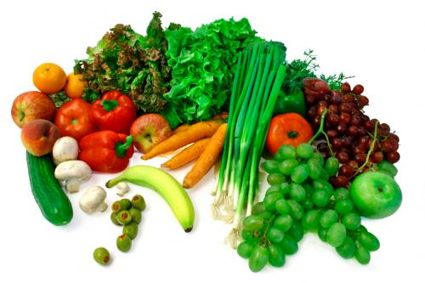

**DEFINITIONS**

**OVERWEIGHT –** having weight excess than normal, harmless unless accompanied with over fatness

**OVER FAT –** person having more fat than recommended for gender and age

**OBESE –** term used to describe people who are very over fat

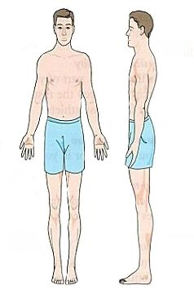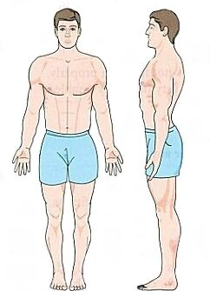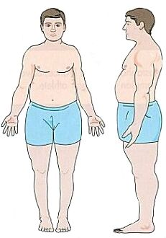

**WHAT ARE THE DIFFERENT SOMATOTYPES?**

**ECTOMORPH**

* Slightly built, delicate body
* Narrow shoulders and hips
* Lean, fragile
* ***E.G. Marathon Runner***

**ENDOMORPH**

* Round/ ‘pear drop’ shape
* Narrow shoulders and broad hips
* Carry weight around waist and on hips and upper thighs
* ***E.G. Sumo wrestler***

**MESOMORPH**

* ‘Athletic Build’
* Muscular, large trunk
* Broad shoulders, narrow hips
* ***E.G. 100m Sprinter***



**B1 - PREVENTION OF INJURY**

**SECTION B: Safety aspects & risk assessment in sport & physical activity**

**Understand Rules of the game**

**Warm-up and cool-down practices**



**HOW TO PREVENT INJURY**

**Balance competition in terms of**

|  |  |
| --- | --- |
| * **Grading** * **Skill levels** * **Age** | * **Weight** * **Sex** |

**Wearing correct clothing/footwear;**

**Protective clothing/equipment for different sports**

**B2 - SPORTS INJURIES**

**EMERGENCIES – WHEN SOMEONE COLLAPSES**

**RECOVERY POSITION**

When a person is unconscious we place them in this position to prevent them:

1. from being sick
2. from choking
3. from their tongue falling back and blocking the airway

After placing a person in this position, dial 999 for help. You must keep checking their breathing every 2-3 minutes until help arrives.

|  |  |  |
| --- | --- | --- |
| **D**ANGER | Ask - am I in danger? ... Is the collapsed person in danger?  Send for medical help | |
| **R**ESPONSE | **Conscious** | **Unconscious** |
| **A**IRWAY | * Make comfortable * Check Airway, Breathing, Circulation * Check for injury | * Put in recovery position * Clear airway & tilt head * Look, listen, feel for breathing |
|  |  |
| **B**REATHING | **Breathing**   * Keep in recovery position * Check Airway, Breathing, Circulation * Check for injury | **Not Breathing**   * Put on back * Start mouth to mouth ventilation * Give 2 full breaths * Check circulation |
|  |  |
| **C**IRCULATION | **Pulse Present**   * Keep on back * Continue M.M.V * Check pulse & breathing | **Pulse Absent**   * Start cardiopulmonary resuscitation **(CPR)** * Check pulse & breathing |

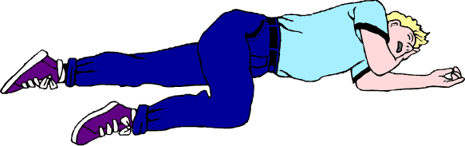

**RECOVERY POSITION**

We place an unconscious person in this position to prevent them:

* From being sick
* From choking
* From their tongue falling back and blocking the airway

After placing a person in this position, ***dial 999 for help***.

You must keep checking their breathing every 2-3 minutes until help arrives.

**SPORTS INJURIES continued…**



**HARD TISSUE INJURIES**

These are injuries to the bone and include;

* Fractures
* Dislocations

**FRACTURES** – break in the bone. There are two types;

* 1. ***Simple (closed) fracture***– bone stays under the skin
  2. ***Compound (open) fracture*** – Bone breaks through the skin

*All fractures are serious and need **URGENT** medical attention*

**STRESS FRACTURES** – Small cracks in the bone. Often an overuse injury and caused by running too much in a hard surface. We need to;

* Use ice to reduce inflammation
* Get immediate rest
* Keep fit doing over activities
* Check running and footwear for problems

**DISLOCATIONS** – Bone at a joint is forced out of its normal position.

Also could be possible ligament damage around the joint. Could be caused by strong force wrenching the bone e.g. rugby tackle.

***All dislocations should be treated as a fracture.***

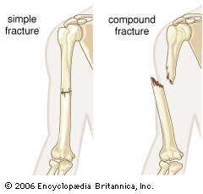

**2**

**1**

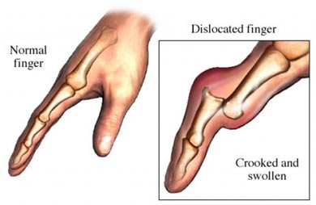

**SOFT TISSUE INJURIES**

Includes;

* Sprains
* Strains
* Cartilage damage
* Tendon and ligament damage
* Minor injuries – cuts, grazes and bruises

**TREATMENT – R.I.C.E**

**REST –** Rest the injured part to prevent further injury

**ICE –** Apply ice or a cold compress to reduce blood flow, pain and swelling

**COMPRESSION –** Compress the injury to reduce bleeding and swelling

**ELEVATION –** Elevate the injured part to reduce bleeding, swelling and throbbing

**BONE & JOINT INJURIES**

**RECOIGNITION**

* Recent blow or fall
* Snapping sound
* Difficulty moving limb
* Pain worse when moving
* Deformity – limb unusual shape
* Swelling, bruising
* Signs of shock

**ACTION**

* Keep him/her still & comfortable
* Support injured part
* Bandage injured part to their body/limb
* Reassure him/her
* Send for medical help

The 3 parts of the circulatory system are blood, heart and blood vessels

Heart

**THE HEART**

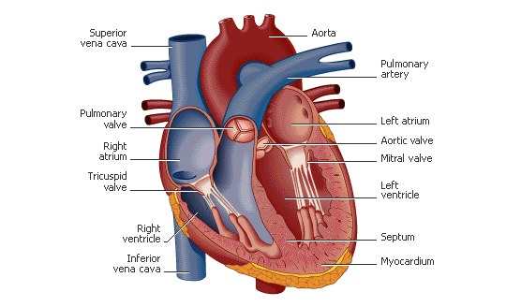

**C1 - THE CIRCULATORY SYSTEM**

**KEY TERMS**

* **Heart Rate (HR)** – the amount of beats per minute
* **Stroke Volume** **(SV)** – the amount of blood pumped by heart in one beat
* **Cardiac Output** **(CO)** - the amount of blood pumped by the heart in one minute

**CO = SV X HR**

**Section C: Applied anatomy & physiology**

**WHAT ARE THE COMPONENTS OF THE BLOOD?**

* **Red blood cells** – made in bone marrow of long bones. Carry oxygen and transport nutrients and waste products
* **White blood cells** – made in bone marrow and lymph tissue. Protect body from disease
* **Platelets** – in charge of blood clotting. Clotting is important to stop blood loss from the body and stop internal bleeding
* **Plasma** – made up of mostly water and makes up 55% of volume of blood; helps blood fluidity

Lungs

**Pulmonary Circuit**

**Systemic Circuit**



**Arteries**

**Veins**

**THE FLOW OF BLOOD**

De-oxygenated blood returns to the heart through the large veins called venae cavae

It is pumped through semi-lunar valve into aorta and out to rest of body through arteries

Carotid artery

Femoral artery

Brachial artery

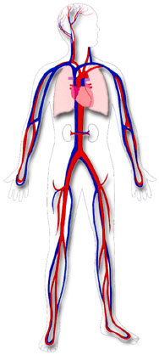

**Capillaries:**

* Smallest of all vessels – walls one cell thick
* They are ‘semi-permeable’ – substances pass through
* At one end – they feed muscles, organs and body tissue with oxygen and nutrients
* At other end – carbon dioxide and waste products pass into veins to be removed
* They bring blood within reach of every cell

**Veins:**

* Thin walls
* Valves present; prevents backflow. No pulse
* Pulsating muscles close to veins prevent backflow- ‘*skeletal pump’*
* Work under low pressure
* Transports blood towards the heart (DEOXYGENATED)
* Wide lumen

**WHAT ARE ARTERIES, VEINS & CAPILLARIES?**

**Arteries:**

* Thick, flexible vessel walls
* Has a pulse. No valves
* Work under high pressure
* Transports blood away from heart (OXYGENATED)
* Narrow lumen

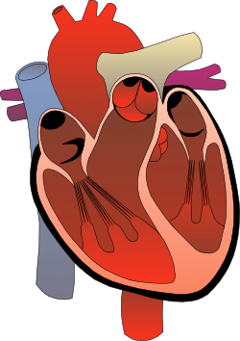

It passes through bicuspid valve and into the left ventricle

Blood enters right atrium and passes through the tricuspid valve into right ventricle

Oxygenated blood returns to heart from lungs through the pulmonary vein into left atrium

It is then pumped through the semi-lunar valve into pulmonary artery and into lungs where it loses carbon dioxide and picks up fresh oxygen

The 3 parts of the respiratory system are the diaphragm, lungs and air passages

**THE RESPIRATORY SYSTEM**

The function of the respiratory system is;

* To get oxygen into the body
* To remove carbon dioxide out of the body

Oxygen is used by the body to release energy and carbon dioxide is released so it doesn’t build up and poison the body

**C2 - THE RESPIRATORY SYSTEM**

|  |  |
| --- | --- |
| When we breathe in – **Inspiration** – the following happens… | When we breathe in – **Expiration** – the following happens… |
| * Our diaphragm pulls down * Our intercostal muscles contract * Air pressure is reduced * Air is sucked through the tubes into lungs * Our chest expands | * Our diaphragm relaxes * Our intercostal muscles relax * Our chest becomes smaller * Pressure increases on the lungs * Air is forced out |

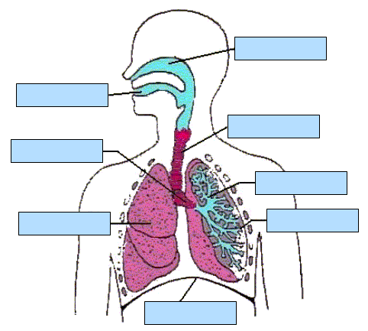

**COMPOSITION OF AIR**

**EXHALED AIR**

* 79% - Nitrogen
* 16% - Oxygen
* 4% - Carbon dioxide

**INHALED AIR**

* 79% - Nitrogen
* 20% - Oxygen
* Trace - Carbon dioxide

**WHAT IS LACTIC ACID?**

* Lactic acid is a bi-product of exercise. A build up of this can inhibit performance and cause pain, discomfort and fatigue.
* Lactic acid occurs in the anaerobic system because without the presence of oxygen, pyruvic acid turns to lactic acid.
* Cooling down properly with stretching helps the lactic acid be removed and prevents aching muscles after the exercise.

**AEROBIC and ANAEROBIC ACTIVITY**

**AEROBIC** – with oxygen

* Lower intensity
* Endurance activities – Marathon

**Formula –** Glucose + Oxygen Carbon dioxide, Water, ENERGY

**ANAEROBIC –** without oxygen

* Higher intensity
* Short distance activities – Sprinting

**Formula** – Glucose + Oxygen Carbon dioxide, Water, ENERGY,



Lactic acid



**MECHANISM OF BREATHING**

Lungs are not muscles therefore can’t move on their own accord. They are helped by the ***diaphragm*** and ***intercostal muscles*** between the ribs.

**KEY TERMS**

* **Oxygen debt –** Shortfall of oxygen to the body after maximal effort/anaerobic exercise, resulting in deep and shallow breathing
* **Vital Capacity –** The maximum amount of air that can be forcibly exhaled after breathing in as much as possible
* **Tidal Volume –** Amount of air breathed in or out at rest

**HOW ARE BONES CLASSIFIED?**

1. **Long bones** – Humorous, Femur
2. **Short bones** – Carpals and Tarsals.
3. **Flat bones** – Cranium, Scapula and Sternum
4. **Irregular bones** – Patella and Vertebrae. (odd shaped bones )



**WHAT ARE THE FUNCTIONS OF THE SKELETON?**

1. **Protection** – Ribs protect heart and lungs, Cranium protects brain.
2. **Shape** – gives framework - basketball player long, thin skeleton - jockeys small, thin skeleton
3. **Support** – firm, rigid and keep us upright.
4. **Movement** – Skeleton has ‘anchor points’ to which muscles attach and act as levers. ***Long bones*** help creates the leverage to apply the force.
5. **Blood Production** – red and white blood cells are produced in the long bones.

**C3 – BONES**

**WHAT ARE THE 5 SECTIONS OF THE VERTEBRAE?**

**Come**

**To**

**Learn**

**Spinal**

**Column**

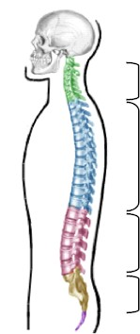

1. **Cervical** – 7 vertebrae forms the neck and allows movement at top of the spine.
2. **Thoracic** – 12 vertebrae. 10 are attached to ribs and help movement whilst breathing.
3. **Lumbar** – 5 large and robust vertebrae. This area allows most movement.
4. **Sacrum** – 5 vertebrae which become fused together in adulthood. They form part of the pelvic girdle.
5. **Coccyx** – 4 vertebrae here, all fused together.

Cranium

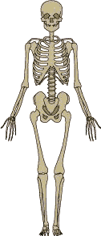

Scapula

Clavicle

Sternum

Humerus

Ribs

Ulna

**THE DEVELOPMENT OF BONES**

Bones start off as cartilage and then become bone by the process of **Ossification.**

Bones have a tough outer layer called the **Periosteum**

As development continues there are 3 centres of ossification: in the ***diaphysis*** (middle) and ***epiphyses*** (end).

**Ossification** - The development of bone from cartilage. It occurs throughout childhood until adulthood.

Radius

Carpals

Ilium

Phalanges

Metacarpals

Femur

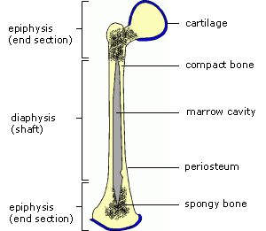

Patella

(Growth plate)

Tarsals

Tibia

Phalanges

Metatarsals

Fibula

**WHAT TYPES OF JOINTS ARE THERE?**

1. Fixed (fibrous) joints - ***Skull***
2. Slightly moveable (cartilagineous) joints - ***Vertebrae***
3. Synovial joints or Freely Moveable – ***Knee/Elbow***

**IN WHAT WAYS DO JOINTS MOVE?**

1. **Flexion**: decreasing the angle at a joint.
2. **Extension**: increasing the angle at a joint.
3. **Adduction**: movement of a limb towards the body
4. **Abduction**: movement of a limb away from the body.
5. **Rotation:** movement of a limb in a circular or part circular direction.

**C4 - JOINTS, TENDONS & LIGAMENTS**

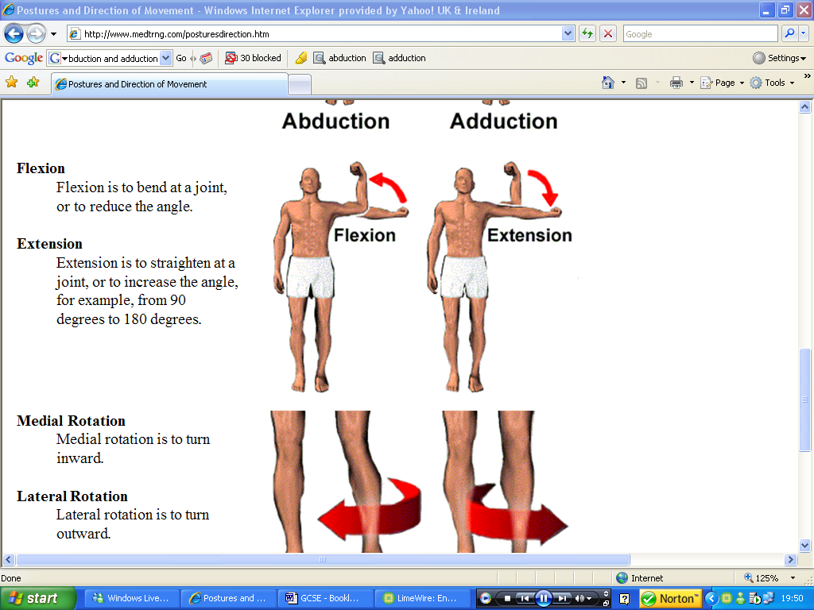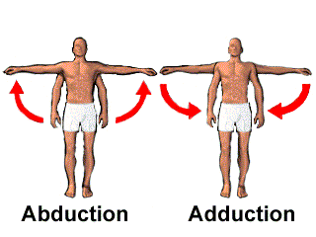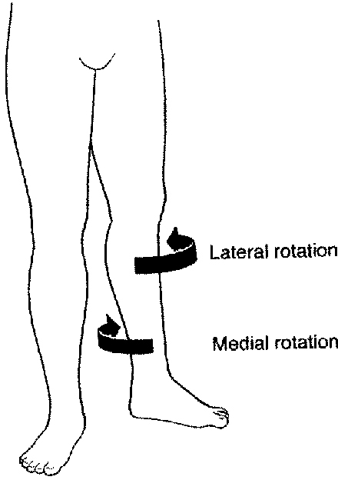

**Rotation**

**SYNOVIAL JOINT**

**Example – The Knee**

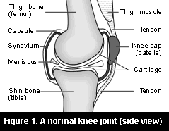

**WHAT TYPES OF SYNOVIAL JOINTS ARE THERE?**

1. **Ball and Socket** – movement in all directions and rotation - Hip, Shoulder
2. **Hinge** – movement Flexion and Extension - Knee or Elbow
3. **Pivot** – only rotation at Atlas and Axis at top of the spine
4. **Gliding** – Little bit of movement in all directions tarsals and carpals
5. **Condyloid** – movement forwards and backwards, left to right - in the wrists

**WHAT ARE TENDONS, LIGAMENTS & CARTILAGE?**

**TENDONS**

* Attach muscle to bone
* Strong, non-elastic connective tissue
* Joint stability

**LIGAMENTS**

* Attach bone to bone
* Very strong elastic fibres
* Joint stability

**CARTILAGE**

* Covers joints to allow bones to rub smoothly
* Acts as shock absorber
* Produces synovial fluid

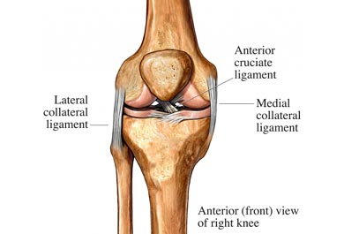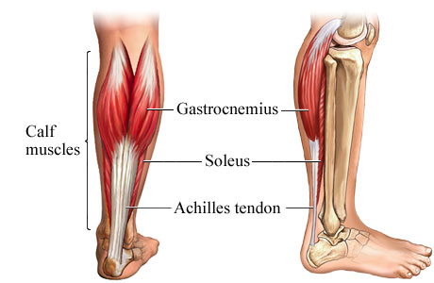

LIGAMENT

LIGAMENT

Bone

Cartilage

Bone

Gastrocnemius

TENDON (Achilles)

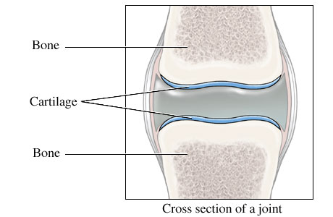

LIGAMENT

**WHAT IS MUSCLE TONE?**

Some muscle fibres contract whilst others relax. These contractions tighten the muscles but aren’t strong to cause movement. Different fibres contract at different times to prevent fatigue. This called ***Muscle tone*** and is very important for good posture.  
  
**MUSCLE TONE *–*** Voluntary muscles in a state of very slight tension ready and waiting to be used

**HOW ARE MUSCLES CLASSIFIED?**

* **Skeletal (Voluntary)** – most common. They attach to the skeleton, give a person’s shape –*Biceps/Triceps*
* **Smooth (Involuntary)** – work automatically and are not controlled - found in *intestines, blood vessels and urinary organs.*
* **Cardiac (Involuntary)** – involuntary and beats rythmatically – *Heart Muscle*

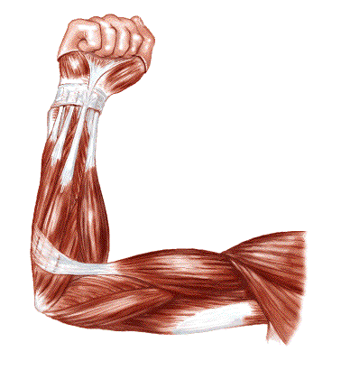

**C5 – MUSCLES AND MUSCLE ACTION**

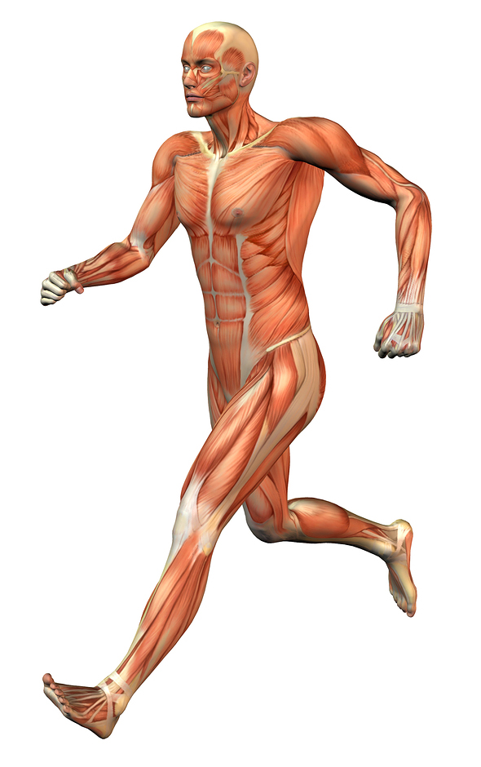

Trapezius

Deltoids

Triceps

Pectorals

**FAST TWITCH OR SLOW TWITCH?**

|  |
| --- |
| **FAST TWITCH** |
| Used in explosive activities |
| Contract quickly |
| Produce powerful action |
| Limited Oxygen supply |
| White in colour |
| e.g. speed events, throwing & jumping |

|  |
| --- |
| **SLOW TWITCH** |
| Used in endurance activities |
| Contract slowly |
| Long Lasting |
| Good oxygen supply |
| Red in colour |
| e.g. long distance running, cycling & swimming |

Biceps

Latissimus dorsi

Abdominals

Gluteals

Quadriceps

Hamstrings

Gastrocnemius

**HOW DO MUSCLES WORK TOGETHER?**

**Antagonistic Pairs:** Muscles working together to provide movement. E.g. Flexion of the arm, biceps contracts and triceps relax. To extend the arm, the triceps contract and the biceps relax.

* **Agonist (Prime mover)** – contracting muscle causing movement
* **Antagonist** – relaxing muscle that assists prime mover
* **Origin** – the end of muscle that is attached to a fixed bone
* **Insertion** – point where a tendon attaches muscle to bone where there is movement
* **Flexibility** – a joint’s ability to move through its full range
* bone where there is movement

Origin

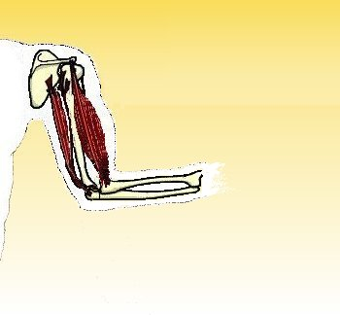

Agonist

Insertion

Antagonist