Physical Demands
Year 10 ELT
Deadline: Tuesday 20th October
- Certain somatotypes are suited to certain sports. Name 3 professional sports people who you believe have a build which is perfectly suited to their sport and explain why their build gives them an advantage in that sport (try to use a different somatotype for each if possible). (9 marks)

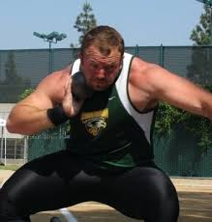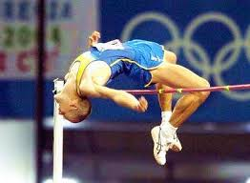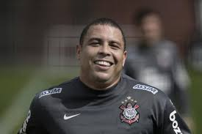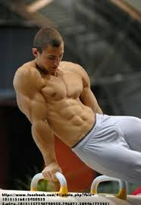
- Some professional sports performers have a build which would make them perfectly suited to a different sport to that which they are known for. Name and describe the build of two professional sports people and explain which sport you believe they could also be successful in due to their build. (6 marks)

Physical Demands
Year 10 ELT
Deadline: Tuesday 20th October
- Certain somatotypes are suited to certain sports. Name 3 professional sports people who you believe have a build which is perfectly suited to their sport and explain why their build gives them an advantage in that sport (try to use a different somatotype for each if possible). (9 marks)

- Some professional sports performers have a build which would make them perfectly suited to a different sport to that which they are known for. Name and describe the build of two professional sports people and explain which sport you believe they could also be successful in due to their build. (6 marks)

